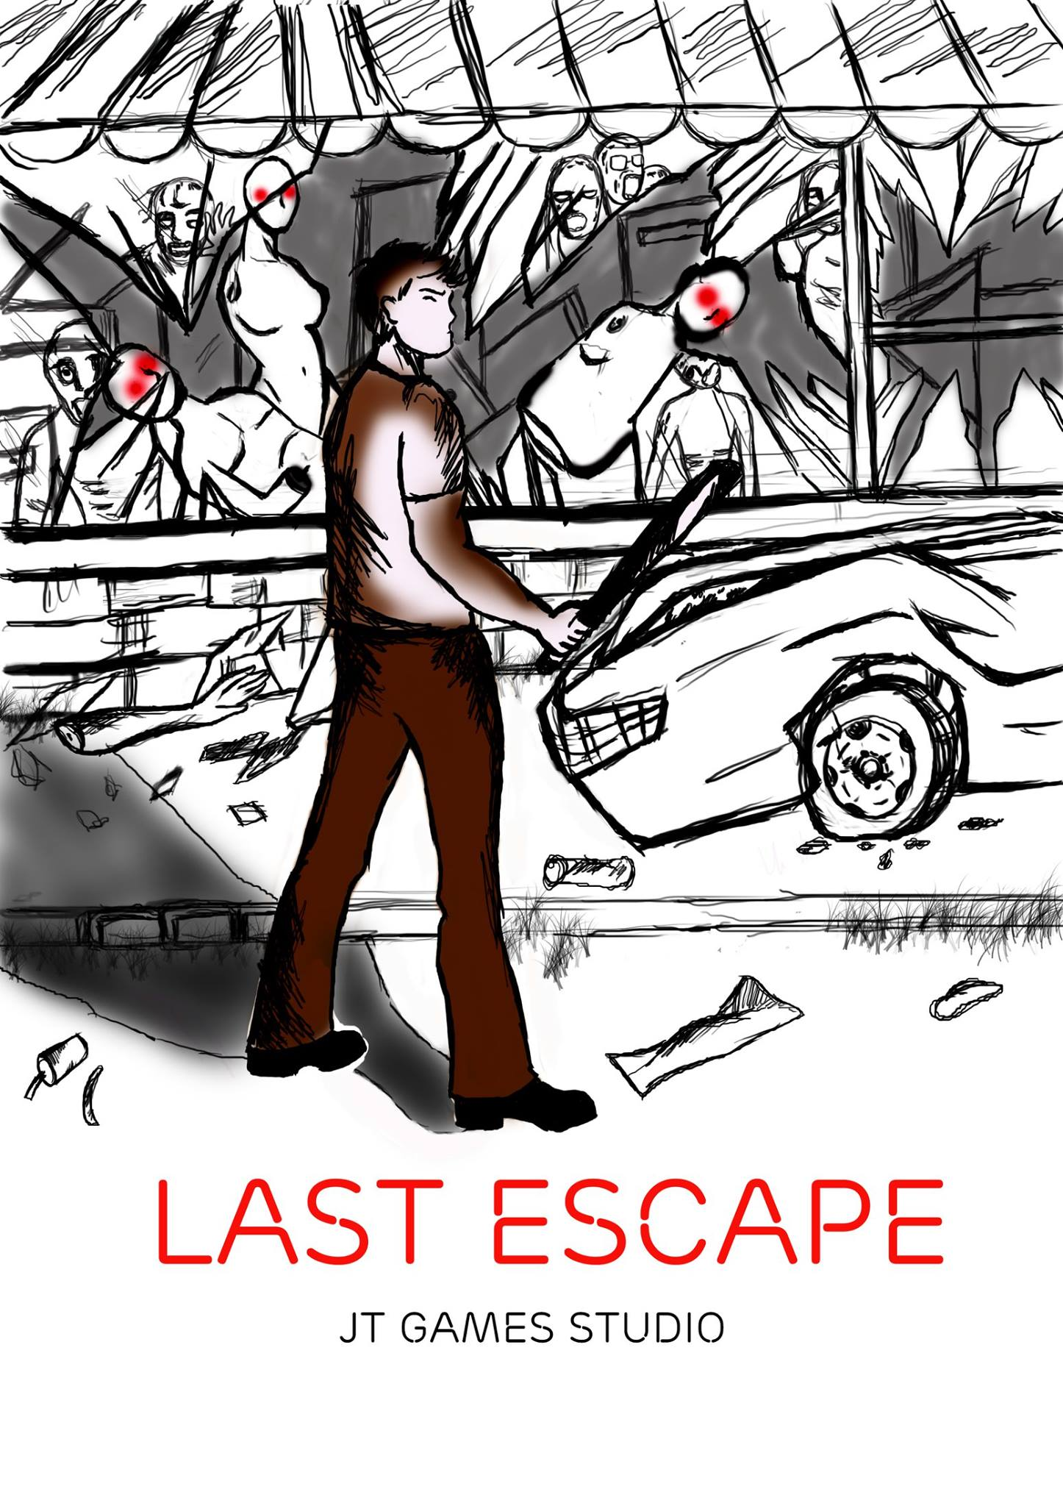

1. Scenario:

In an urban city, there was an outbreak broke out, people who got exposed to the virus turn to carnivore animals and thirst for human flesh as they doing so the infection spread wider.

The city/town can be on a standalone island that connected to the mainland with suspended bridges and underground cable sewer way, or a mainland city surrounded by jungle or desert which can be easily to erect fences/walls to contain the biohazard.

Story:

The main character lost his family on the first day of the outbreak (this is where player learn about the character and also basic movements, distraction throw-able), then we move on to next 3 days after, allow the character to pick up weapons and learn to combat with weapons (melee, throw-able, and shooting). Then we move on the third weeks, the condition was not better, the government turn the whole town into a science lab, they would stop sending rescue squad and erect fences around the city to gather specimen to create bioweapons and eradicate any leftover resistance or capture survivals for experiment. The choice is now within the player hand, either to survive this hell by escape out of it, or gather evidence to bring the evil government to justice.

1. Script:

1/ First mission (tutorial):

1. Screen Play:

The player and his wife were walking in the park when all hell break loose, panic people explosion hit them. The player then got wounded and need to treat wounds himself. They found a med kit on the side near an Ambulance, the player then get instruction on how to do it

Then having the player walk through the people with his family in panic through alleys and encounter one lone zombie, the wife will yell out the instruction how to use the peripherals to punch and kick and to do things. There would be melee weapon to pick up, then player can use the weapon to kill the zombie, or by hand.

After the zombie is defeated, climax of the scene is your family (ie. Wife/husband) got attacked and bit, that character yells out for players. The player now then has to decide between whether to fight or to run for player’s life. Player, of course, can’t kill all of the zombies there, so the player must die. The right choice is to flee rather than staying behind The dead when player decide to fight here and die or failed to escape the situation, game will display message about the important of decision making here.

If the player decided to flee, the alley leads the character to an end with climbable wall and the player escape the situation; hence end the training session

1. Sound:

This part’s music is John Murphy-In the House, without a heartbeat. The chilling intro is where player run through the crowd and then the moment they move through the alley is where the first zombie encounter happens. The song last only the 3 minute, so if the player dragged on then loop the certain high tension part of the song until the zombie is defeated

Sound effect ranging from crowd panic noise, burning noise, police siren those are looped within the main streets.

1. Models:
2. Player:

The player at this state, is indeed empty hand

No Armor

There is no inventory at this moment

1. NPC (partner)

Nothing special

Follow player during the free walking mode

Stand still while player fight off the zombie

Got killed later

2/ Game Starting point:

1. Screen Play:

The player is now survived of the infection, the city is locked down by the government, there is less helicopters flying over to save the survivors. Days get quieter and quieter as if the world forgot about this city and the disaster. Along with a few survivors, player is now packed with basic inventory and searching his own way through and out of the city.

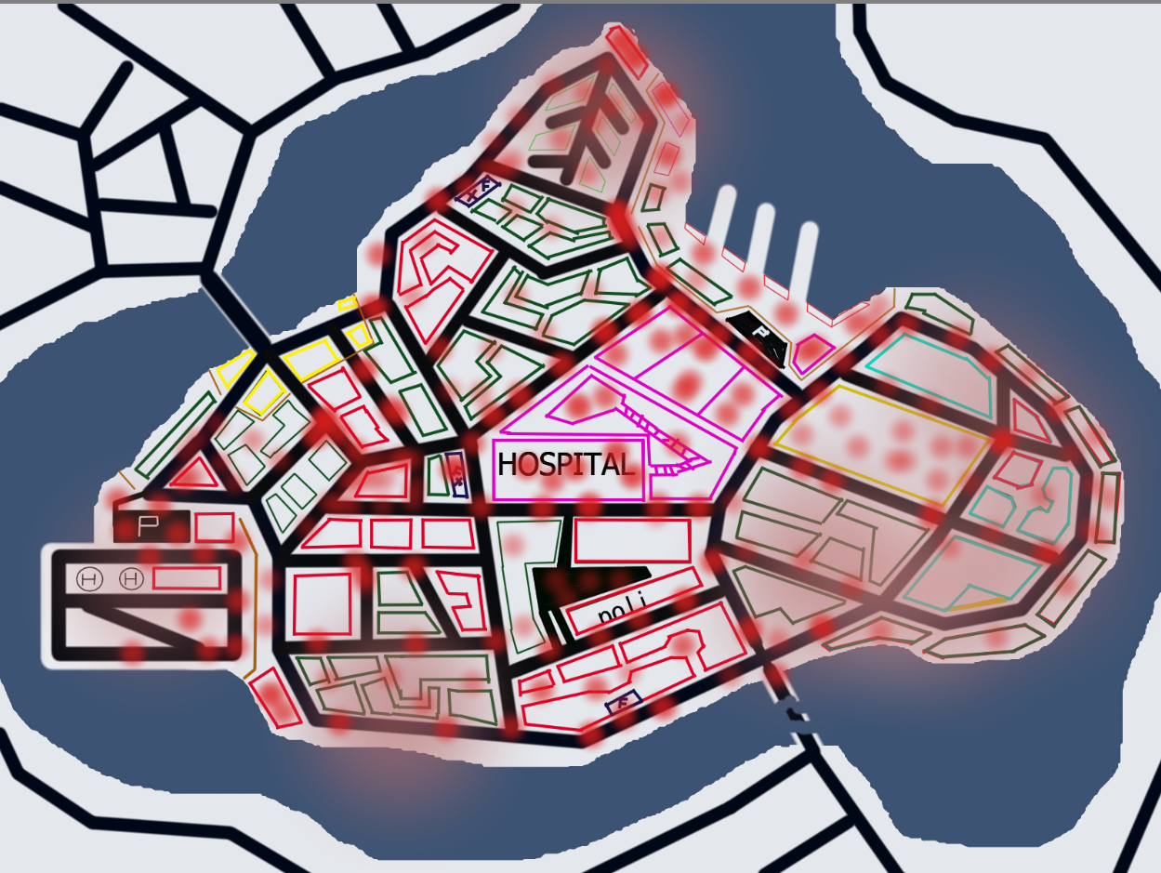

1. Sound:

Howling sounds of zombie, crows sound, chattering

1. Player:

Player has bag, inventory: on

Baseball bat

Small med kit

3/ Goal:

The city has certain areas connected to each other create different routes for different ending:

1/ The first route of escape is through the sewer system of the city, would involve in a two level map design; ground level and sewer level. Player will have to solve puzzle or mathematic questions to solve to open door and gates:

-

2/ Through the main bridge of The urban city section, involving with dealing with delinquents and military, scripts can be from player being stripped out while battling which would involve in some very stealthy actions. Able to gather intelligent and forming alliance to run over military base and release the truth for the world to see:

* The player needs to find the infiltrate point to the base.
* Player got busted and got jailed
* Player needs to break out and decide whether to stop the army or to selfishly escape the city.
* Case A:
  + - * + The player disable/kill military force
        + Which involve in unable to stop the zombies enter the base
        + The base will be remained locked and unable to escape
        + Player must go back and find another route.
* Case B:
  + - * + The player will need to find key card in the base
        + Use that key card at the border gateway and escape through it
        + The cut scene shows that Player escaped unable to find the strength to expose the military idea
      * ACHIEVEMENTS:
        + The base is loaded with information about government plans, if player found this, the ending cut scene will change into Player expose the government plan

3/ Through the river/sea, so there would be a port. Player searching for items, those can be fuel, keys, and side quest character’s requirements to accomplish the goal to be able to get away by the boat. Safely escape the city, and character will live on normally elsewhere:

* Find the key.
* Find the right boat
* Find the fuel (3/3)
* Find the tool kit
* Fix the boat
* Hold the front for – 10 minutes

4/ Through airplane, guessing the scale of the town/city is not a mega city so there would not need for a horizontal take of plane, so the scenario can be trying to escape from a local small airfield with helicopters. The quest would relate to finding fuels and item to start the plane:

- Find the key.

- Find the right Helicopter

- Find the fuel (2/2).

- Find the tool kit.

- Hold the airport for 5 minutes

1. Game mechanic:
2. Player:

1/Statistics:

1. Health:

1/ 100 Health Points:

* + - With wounds vary depend on the Damage Points (DP)
    - Poisonous attack such as zombie bite will degenerate the Health point til zero if player is not treated

2/ 100 Armor points

3/ 100 stamina points

1. Inventory system:

1/ Grid of 5x4

2/ r click item in inventory mode to use

2/ Controls:

* Movement:
  + Player can move forward, backward, left, right, walk with shift key held down or caplock on. Normal running definitely making noise while running, and involve with stamina (-10 stamina every second).
  + Quick roll forward, backward, left, right + alt key (-15 stamina each)
  + Jump with space (- 15 stamina ) and able to clip on certain wall edge(-3 each second), to climb up go forward, to move side way then press the left or right keys (as like clipping)
  + Character can climb ladder/climbable surface as well.
  + Crouch
  + prone
* Interaction:
  + Open door: E key
  + Turn on electronic: E Key
  + Search hint: E key
  + Interact with NPC: E key
  + Turn on/off Flashlight: F key
  + Open inventory: I key
  + Game Menu: Esc key
* Combat:
  + Hand to hand combat:
    - Push- press middle mouse (-5 stamina)
    - Punch – L click (-6 stamina)
    - Kick – R click (-10 Stamina)
    - Grapple (optional) C+L click (-13 Stamina)
    - Execution (neck lock) E (when undetected and behind enemy)
  + Melee:
    - Push- press middle mouse (-2 stamina)
    - Hit – L click (-3 stamina)
    - Energy hit – Hold down L click while moving (-6 stamina)
    - Execution (powerful hit) F (when undetected and behind enemy)
  + Firearms:
    - Shoot – L click
    - Aim – R click
    - Reload – R key
  + Others:
    - 1st weapon: number 1 key
    - 2nd weapon: number 2 key
    - 1st Item: number 3 key
    - 2nd Item number 4 key
    - Use item: L click
    - Use item on other NPC: R click
    - Use item in Inventory: R click